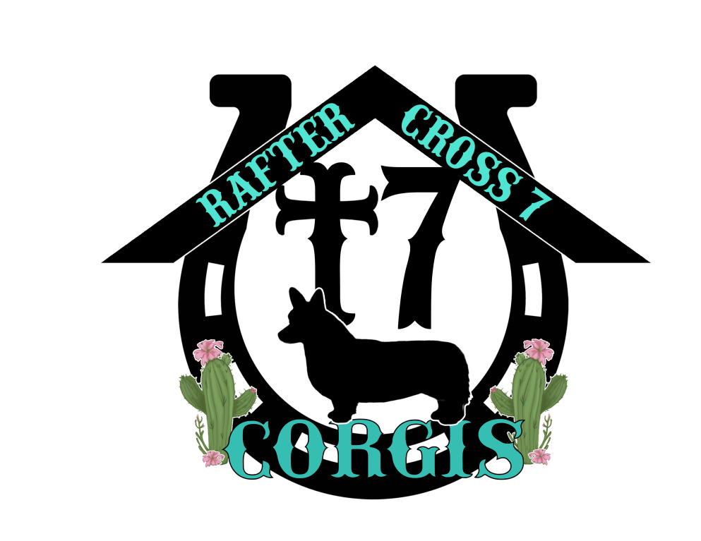

Guardian: ___________________________________________________________

Name and address of Guardian family

Name of Dog: ______________________________________________________
DOB of Dog: ________________________________________________________
Permanent ID: Home Again #______________________________________
Description: ________________________________________________________

ADOPTION FEE: No Fee

OWNERSHIP

Breeder retains technical legal ownership of Dog and puppies produced by Dog. Ownership of the Dog will be transferred to Guardian when Breeder stops using Dog for breeding on or about the 4th year of life or 3-4 litters whichever comes first. This to occur at 4 years of age or shortly after that if pregnancy extends into 5th year , with spay taking place 30 days following weaning of last litter.

BREEDER OBLIGATIONS
- Breeder will visit the Guardian home at least twice annually.
- Breeder will pay all costs related to genetic testing and breeding for the Dog, and provide transportation as possible for those examinations.
- Breeder will provide health certification copies of OFA hip/elbow if applicable and CERF testing for Guardian home records.
- Dog will be kept by Breeder during vacation for Guardian as possible once annually/or as needed during the tenure of the Guardianship. Guardian to give ample notice of such planned vacation dates.
- Breeder will house dog during breeding time and return to Guardian when breeding is completed. Generally this would be a period of 4 days to 7 days.

It will be expected that the Dog will be bred on her second heat or after 12 months old whichever comes first and every heat thereafter according to her health up to the agreed date of termination of breeding rights with spay occurring at that time

GUARDIAN OBLIGATIONS

Guardian to advise immediately when noted that dog has come into heat.
- Guardian understands and agrees that Dog will not be relocated out of the State of California until Dog is spayed and released by the Breeder, on or before the age of four or four litters whichever comes first or following 30 days after weaning of last litter whichever comes first
- Guardian must notify Breeder of scheduled vacations or other absences from the area which might occur during the time the Dog would be in heat. Guardian must assist Breeder to ensure Dog is available to breed at the appropriate time.
- Guardian will notify Breeder of any change in address, telephone number or email address.
- Guardian is responsible for all normal immunization (these to be approved by Breeder in all cases), vet visits, and normal sick dog veterinary fees.
- Guardian may not choose or allow any elective veterinary procedures without consulting Breeder.
- Guardian must secure Breeders approval before placing Dog in someone else’s care, in their absence.
- Guardian will protect Dog from extensive activity which could cause damage to dog. I.E.: excessive jumping in & out of high vehicles, excessive stair use, taking Dog as jogging companion, excessive ball, Frisbee or Flyball type retrieving or activity. These can induce dysplasia symptoms from injury. Normal amounts of these activities are acceptable and desirable.
- It is the Guardian’s responsibility to insure all at-home family members understand and abide by this Contract.
- Guardian will feed Science Diet Dog dog food or any other as requested by Breeder. The contract terminates immediately if the Dog becomes overweight or ill due to neglect of any kind.

Ears must be clear of wax, mites and infection at all times. Dog must be kept free of parasites. Use of Miracle Coat Tea Tree Oil premium shampoo will control these problems. Other info regarding grooming and care will be provided to Guardian by Breeder as needed.
- Guardian and family members agree to attend obedience classes with Dog, at their earliest convenience, and continue socialization as discussed.
- Guardian will not allow any breeding of dog. Such an action immediatley terminates this contract and dog will be returned to breeder.

Illness, Injury and/or Death while under the Guardian’s Care
- Guardian must seek immediate and appropriate care if Dog is injured or becomes ill.
- Breeder is to be consulted in all choices regarding Dog’s medical care, unless emergency care is required and all effort is exhausted to contact Breeder with no success, whereby the Guardian may make the decisions.
- If the dog should die in the guardians care before termination of the contract unless it was extreme negligence, no action will be taken by the breeder

The following responsible dog care would be expected from the Guardian by the Breeder:

A. Contain or supervise Dog in a responsible manner and in a safe environment.

B. Avoid leaving dog alone in a vehicle if the outside temperature is above 60 degrees or below 40 degrees

C. Protect dog from toxic or poisonous materials

D. Avoid leaving the dog in the sole care of a person under the age of 14 years.

The Guardian does not owe money to Breeder if the Dog dies in a manner beyond the control of the Guardian.

Returning Dog

Guardian may return the Dog to the Breeder at any time without explanation and nullify this Contract.

We understand and agree to this Contract

Breeder: _________________________________________________
Brooke Ryan

(Rafter Cross 7 Corgis)
Date:_______________

Guardian: __________________________________________
Signature of Guardian family

Date:________________

